**Name : Aarya Tiwari**

**Roll no : 16010421119**

**Batch : A3**

**Module 1:**

Cluster Initiated: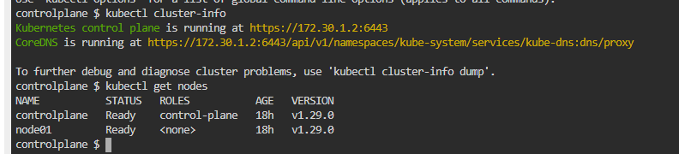

**Module 2:**

Deploying on cluster:  
Nginx deployment:  
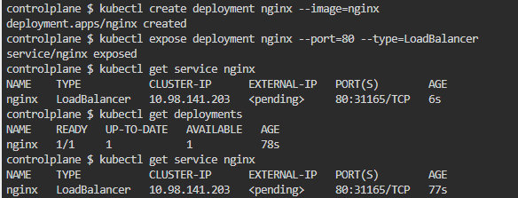

Exposing deployment:

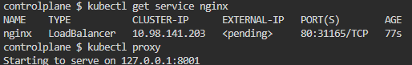

Curling on second tab:

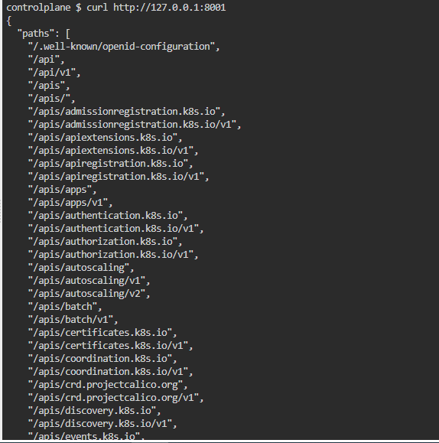

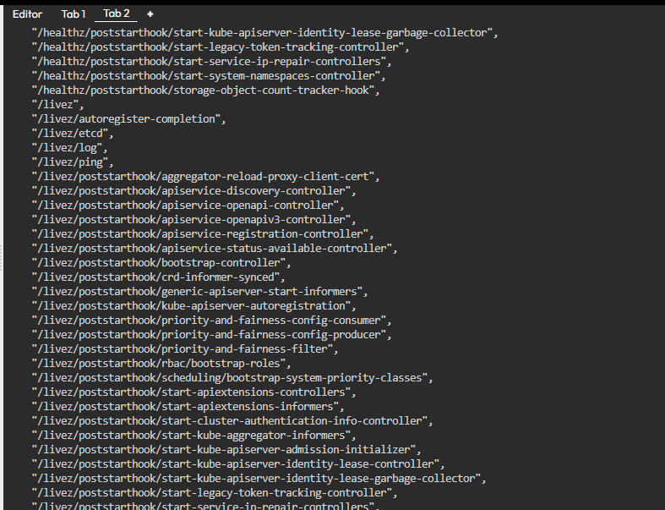

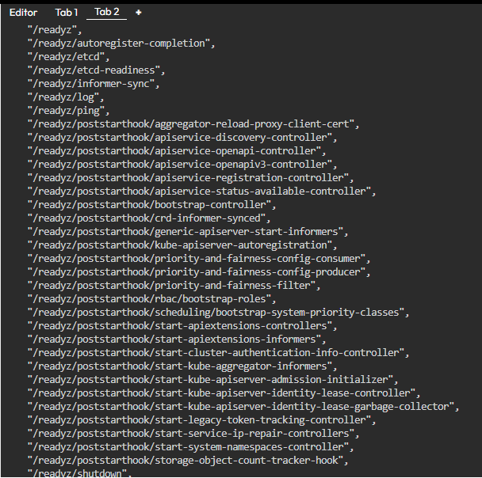

**Module 3:**  
Exploring application:

Get pods:  
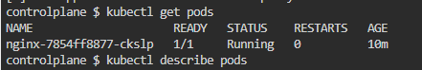

Describe pods:

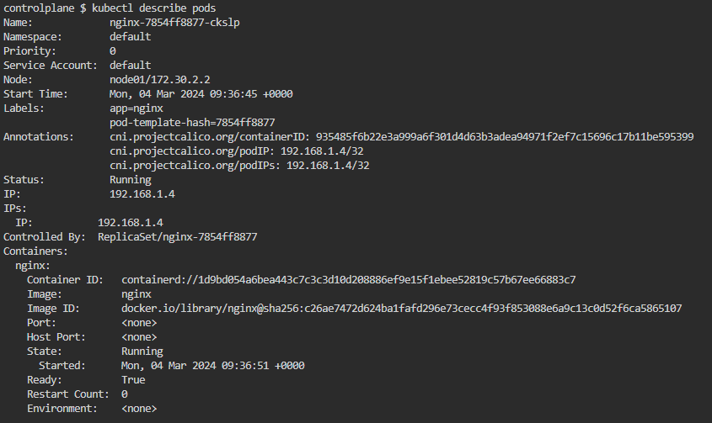

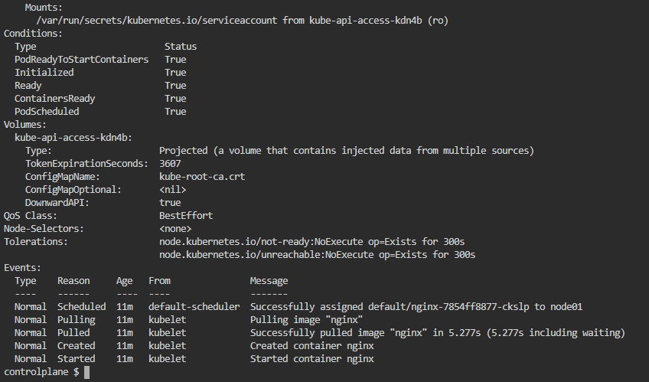

Exposing on proxy:  


Exlporing pods on another tab:  
curl <http://localhost:8001/api/v1/pods>  
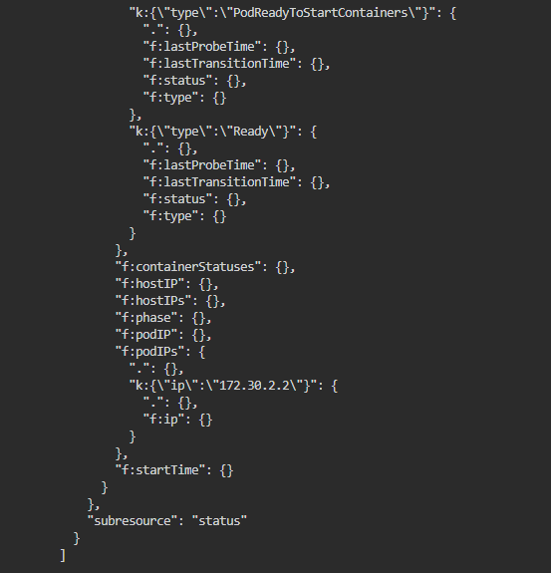

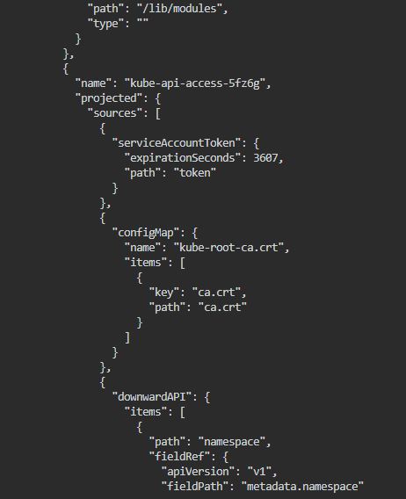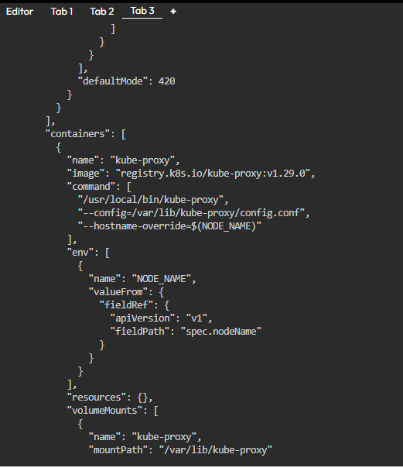

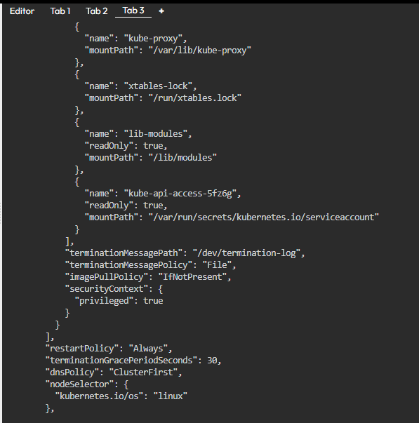

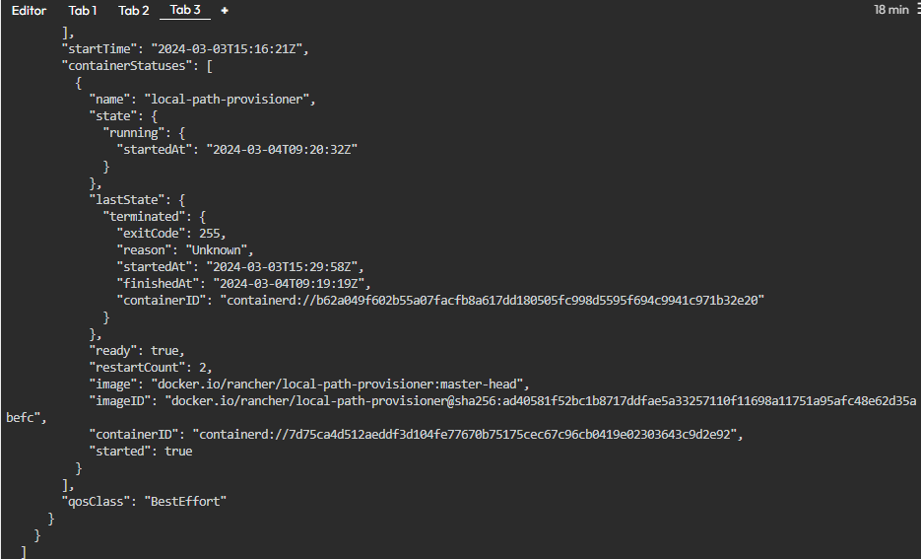

**Outcomes:**

CO4: Examine various security issues in cloud

**Conclusion:**

We can conclude that we have learnt about application deployment using Kubernetes (PaaS)